# Linux Command Line Lab

## Accessing the AWS Management Console

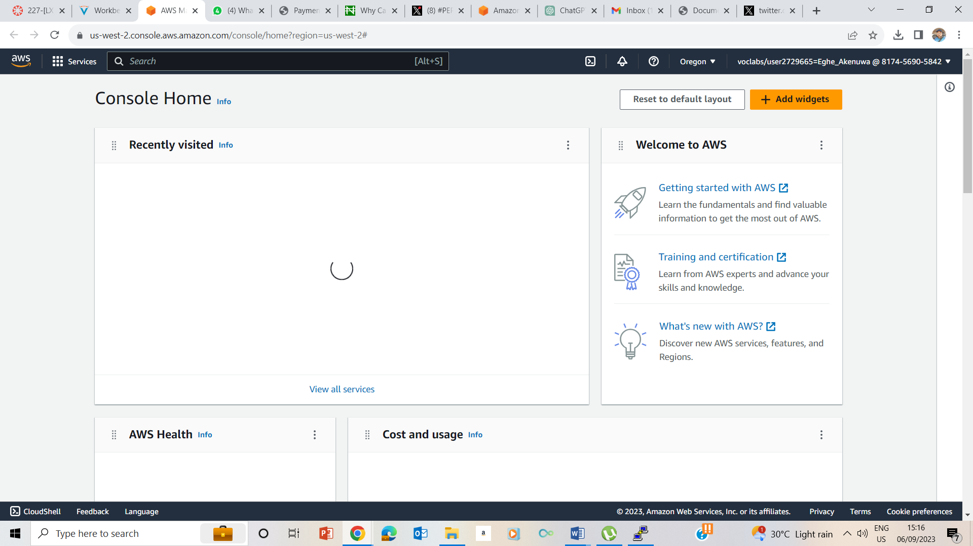

I started the Lab and on its ready prompt, I clicked on AWS button to take me to the AWS Management console

## Task 1: Use SSH to connect to an Amazon Linux EC2 instance

I

### Windows Users: Using SSH to Connect

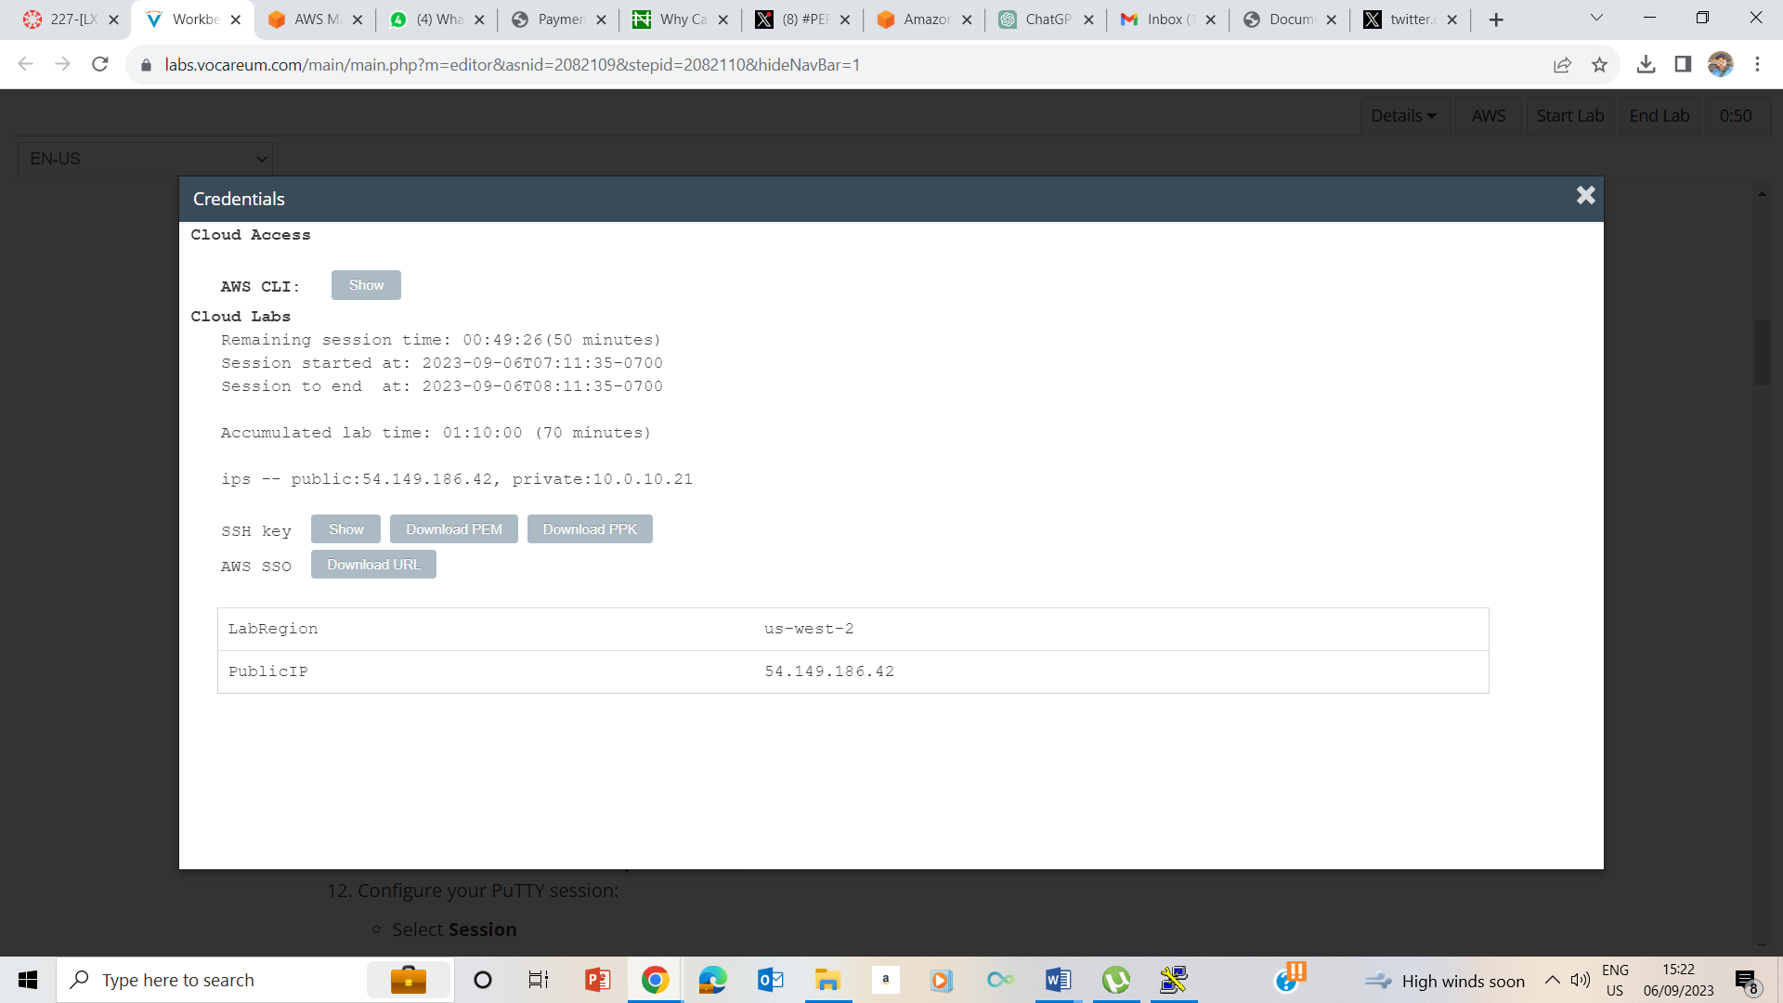

5-7 I clicked on the details drop down box, selected show, downloaded PPK, made a note of the Public Ip address

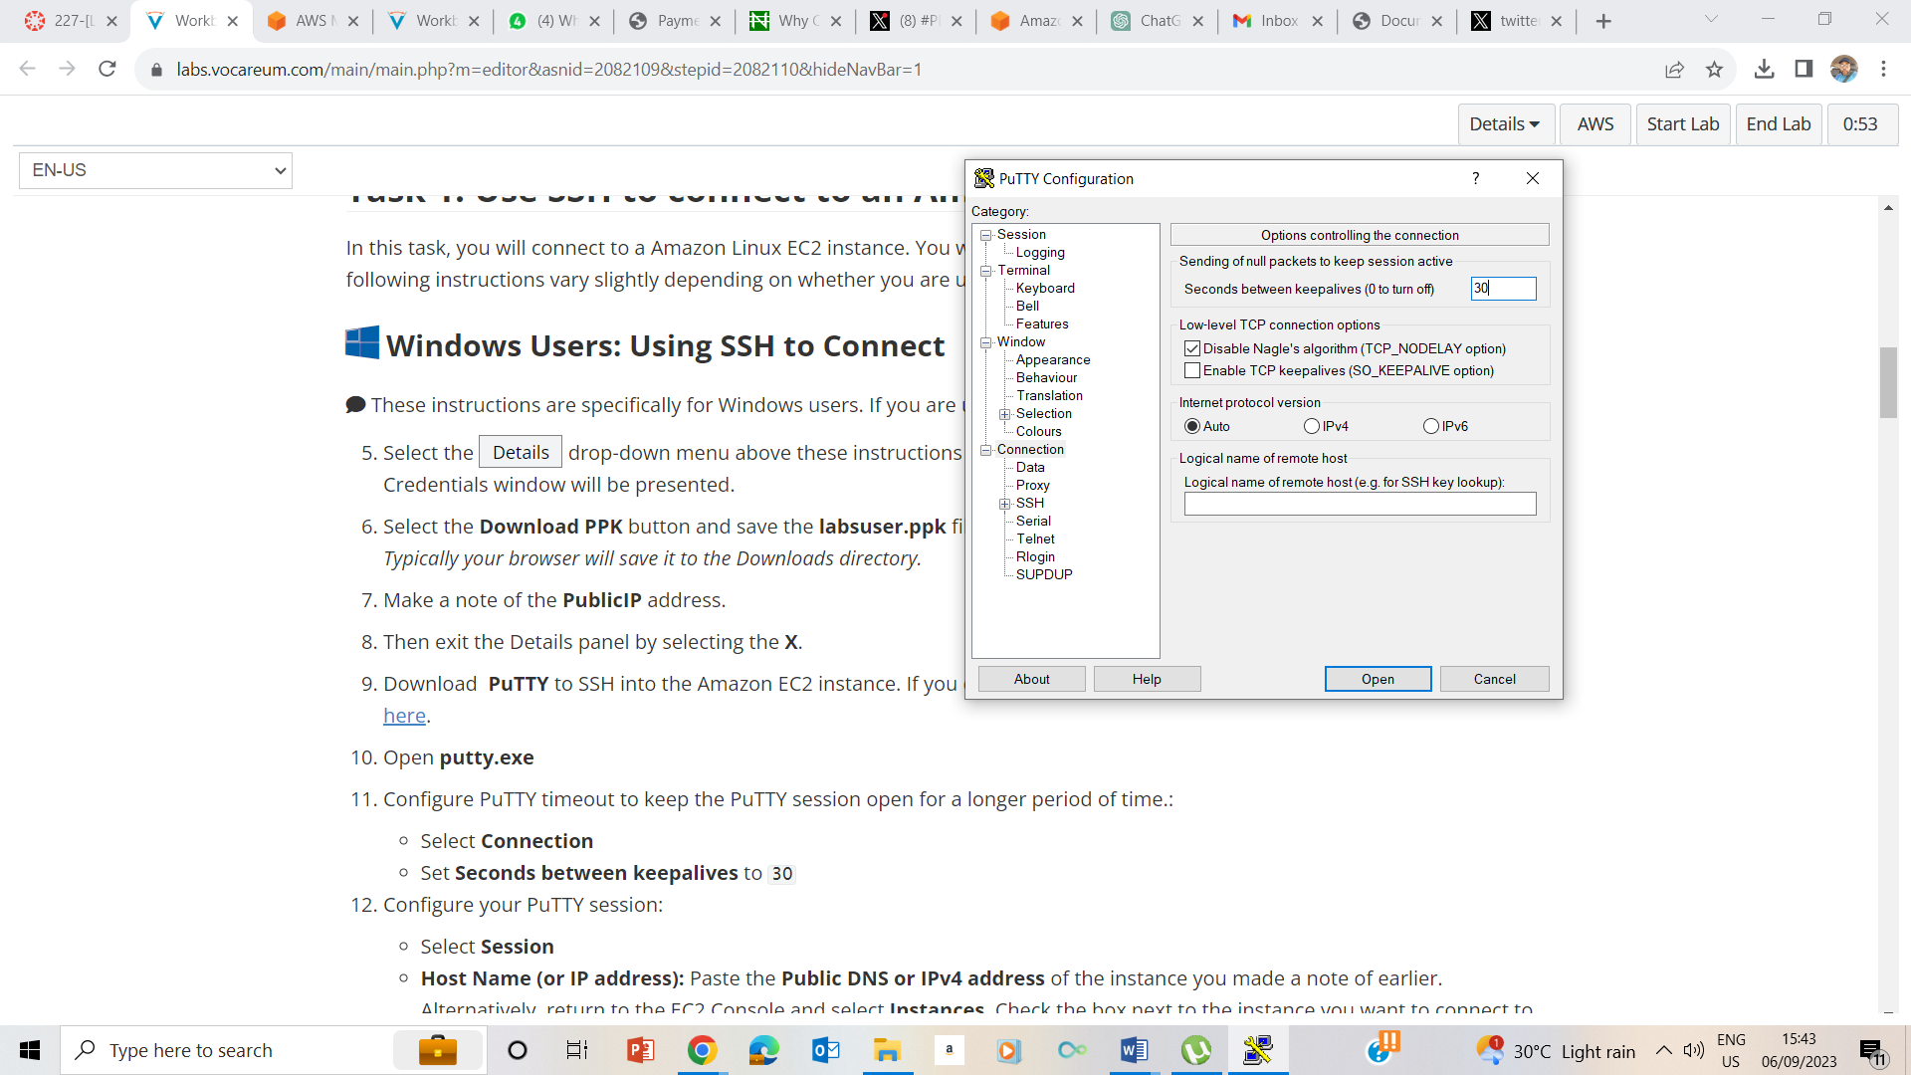

9-10 Downloaded putty, opened putty.exe, selected connection and set the seconds between keepalives to be 30

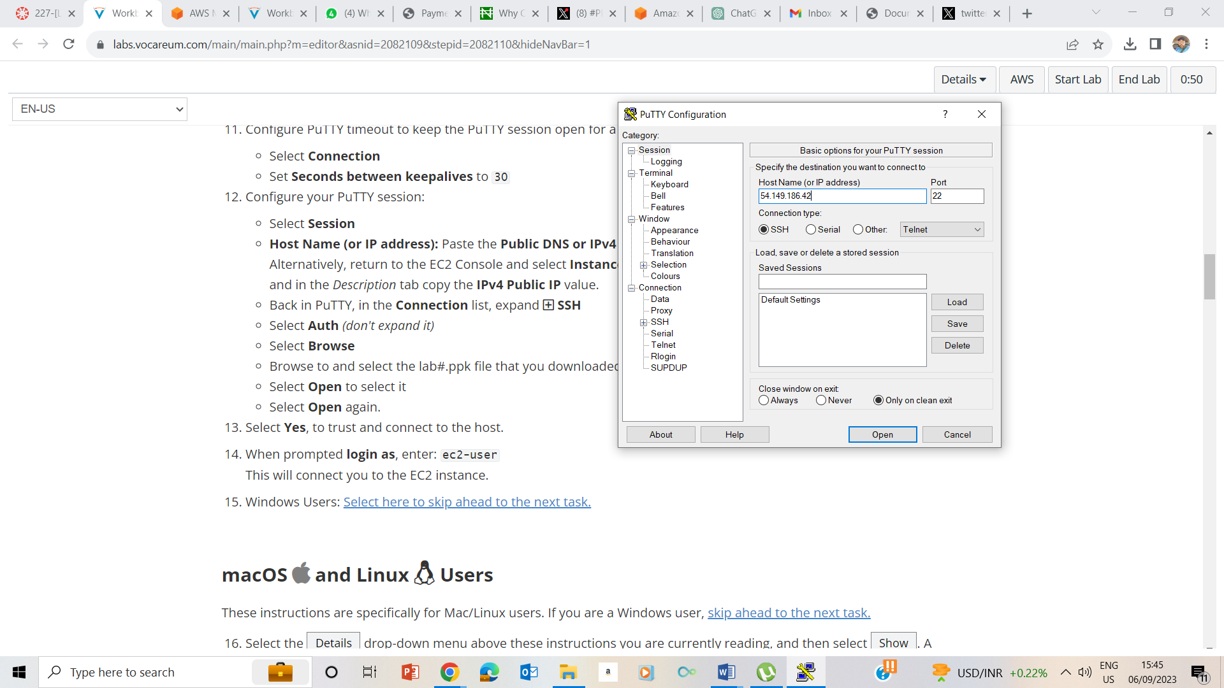

12. selected session , and entered the public ip address in the Host Name (or IP addres s) space and configured the Putty session

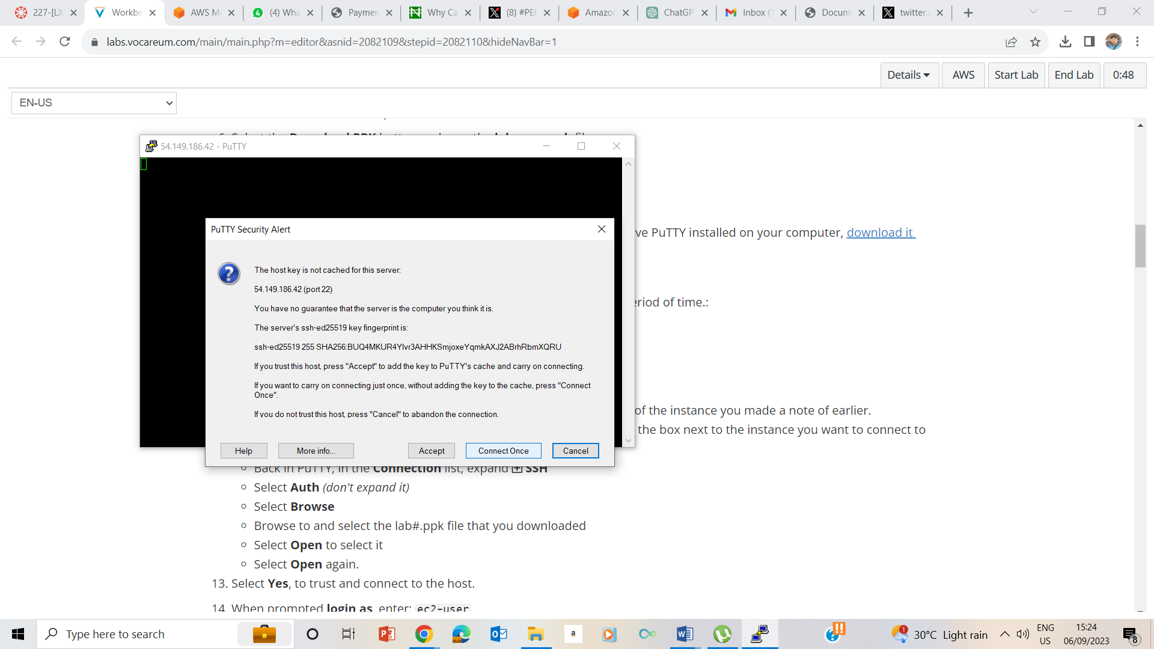

13. Clicked on accept to trust and connect to the host

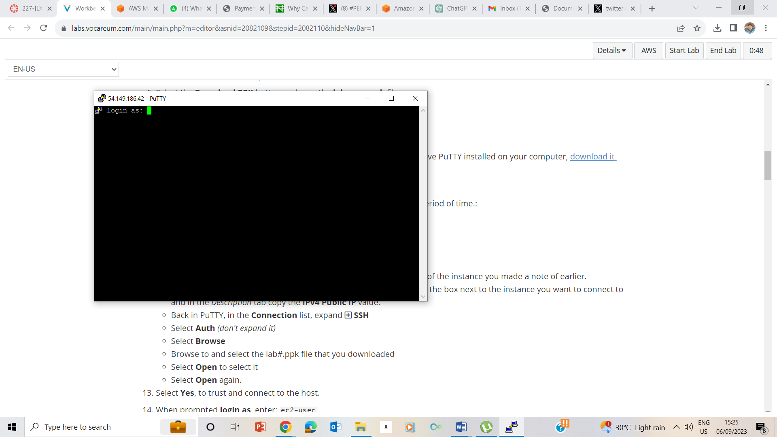

14 logged in as ec2-user

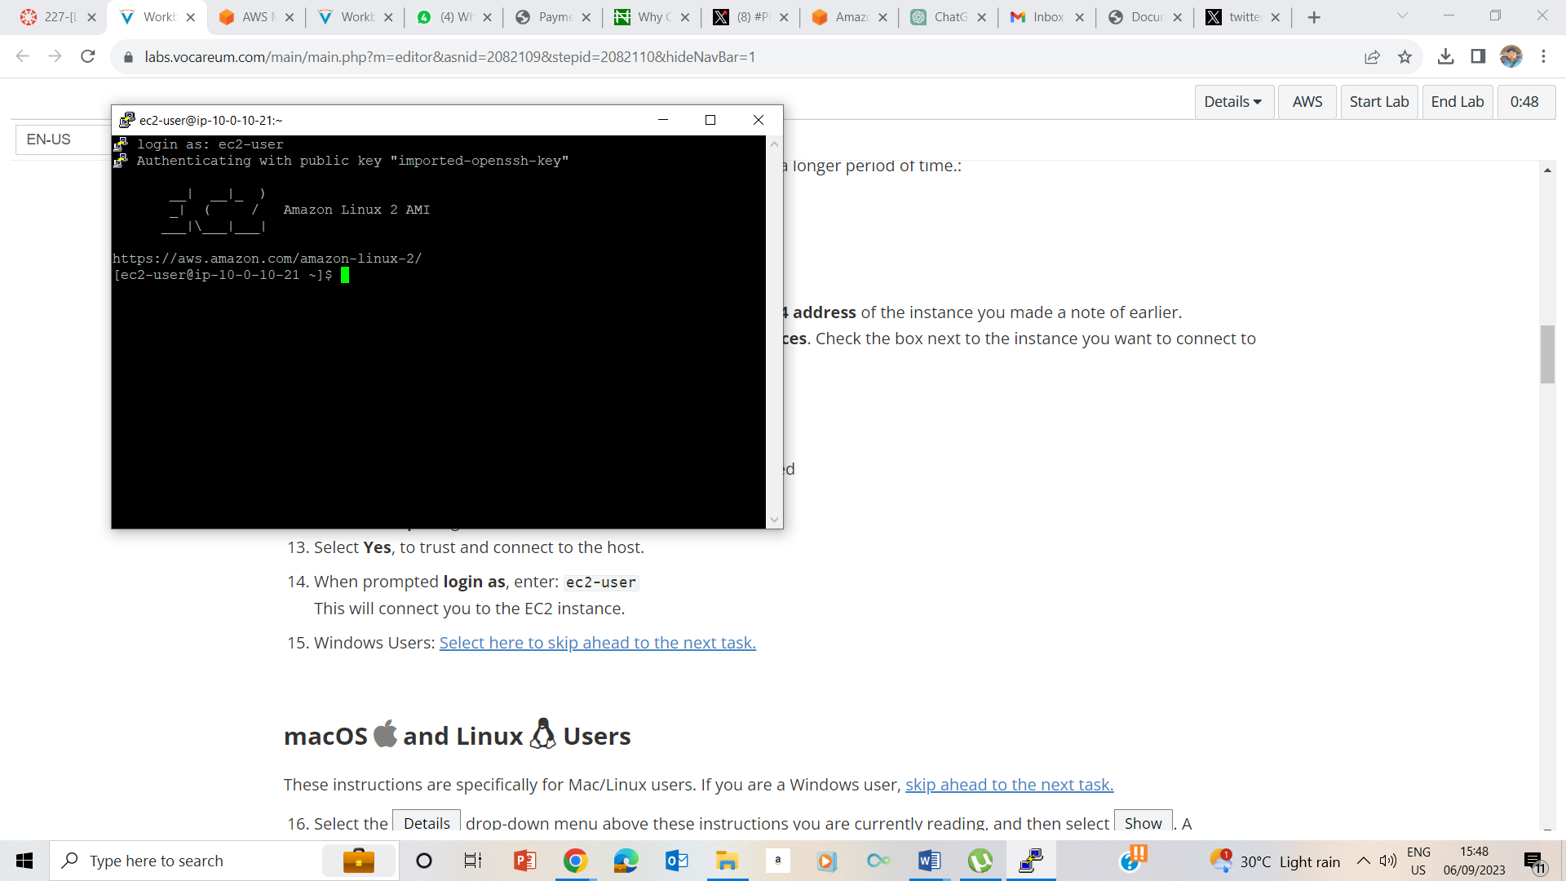

15. connection achieved.

## Task 2: Run familiar commands

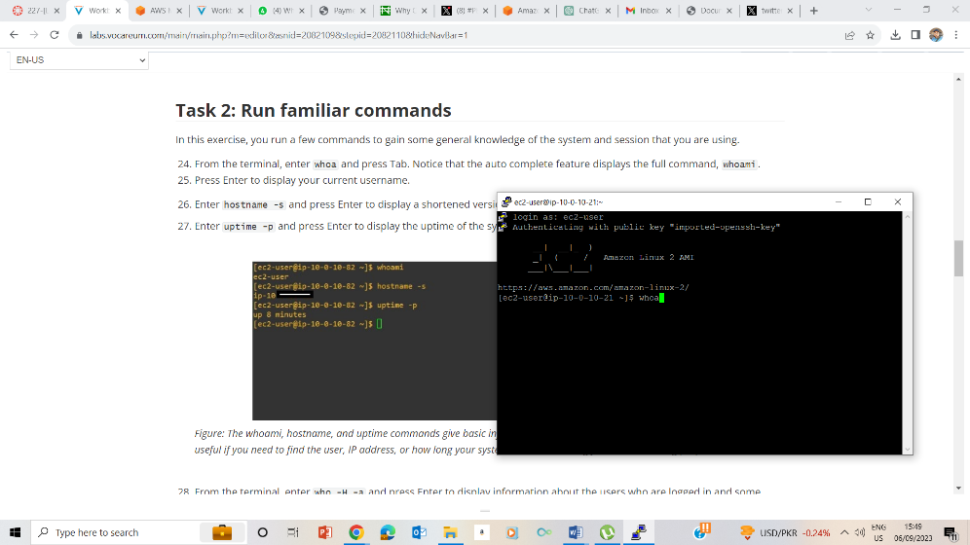

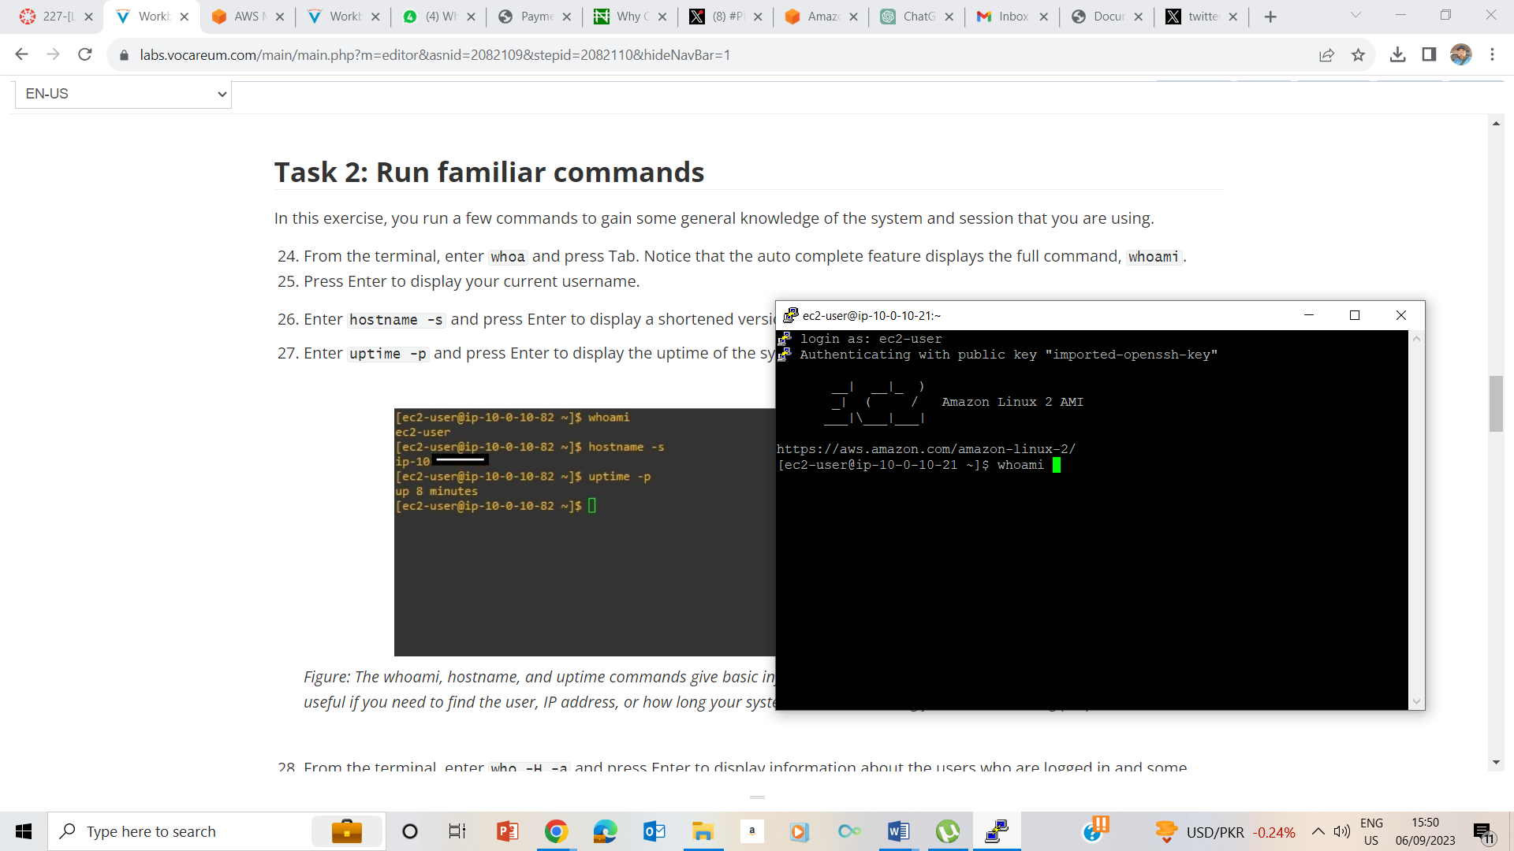

24 whoami command

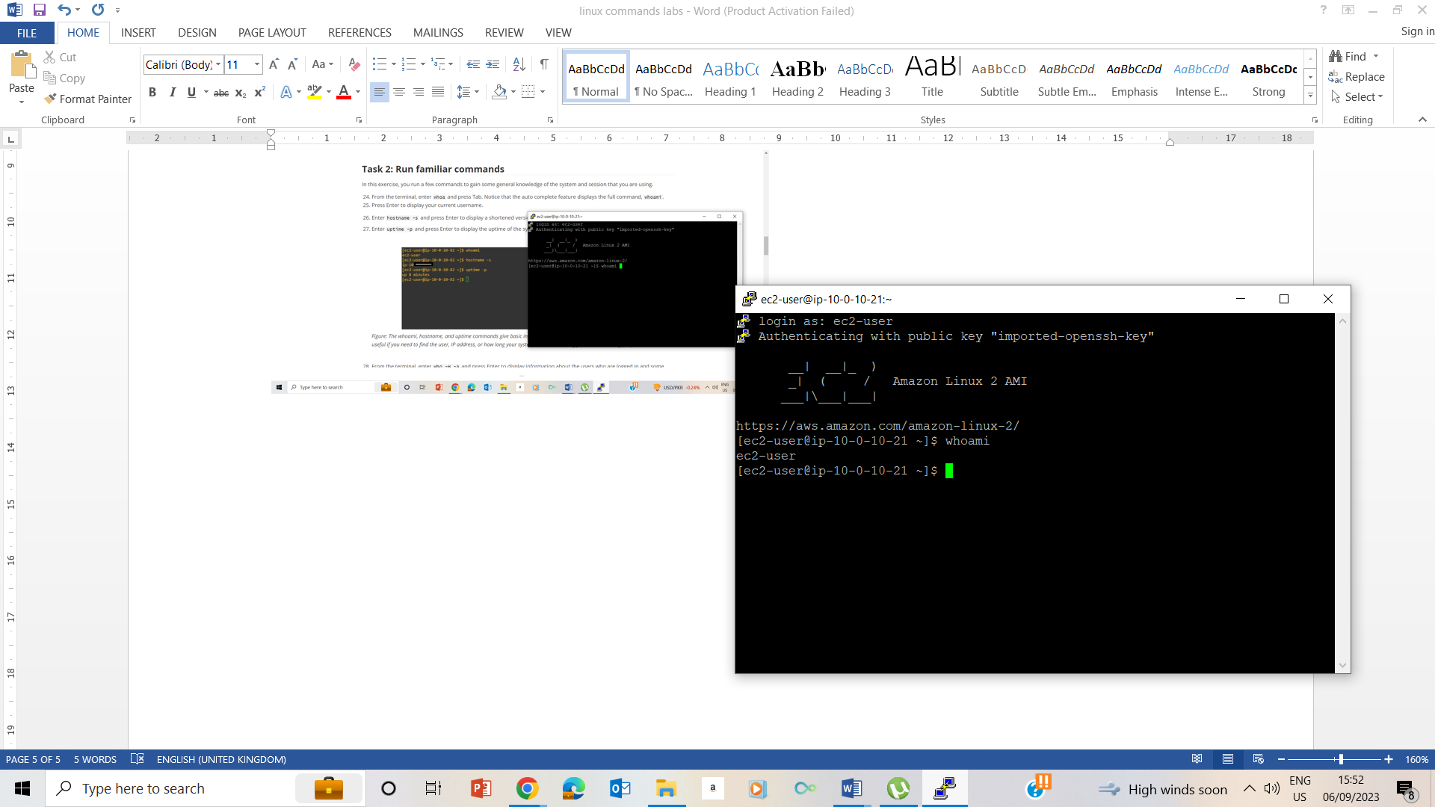

26 & 27 hostname -s

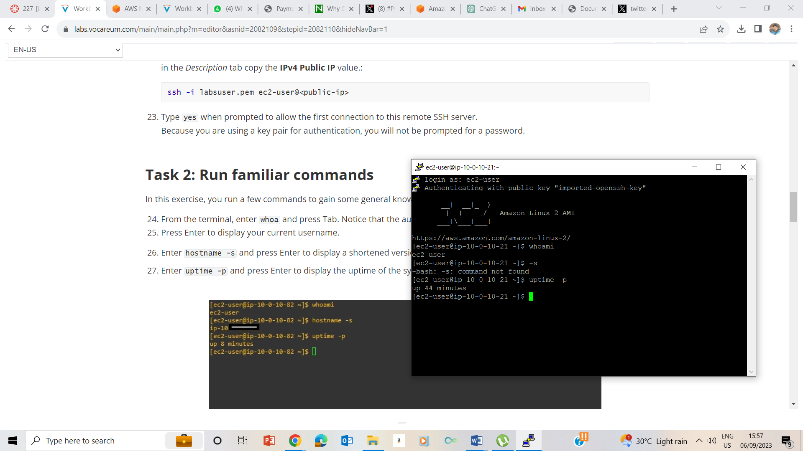

27. uptime –p command

28

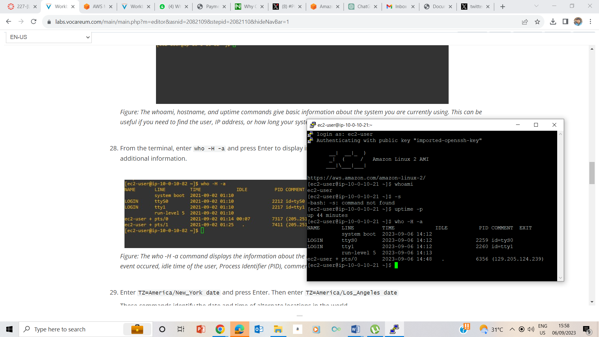

29. who –H –a to display information about users who are logged in.

29

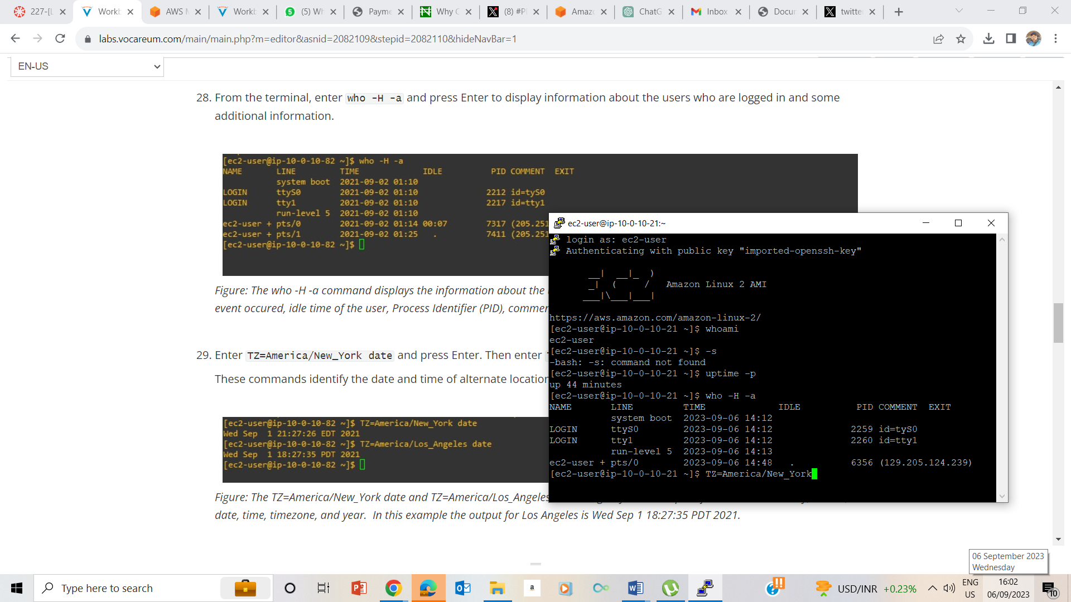

29

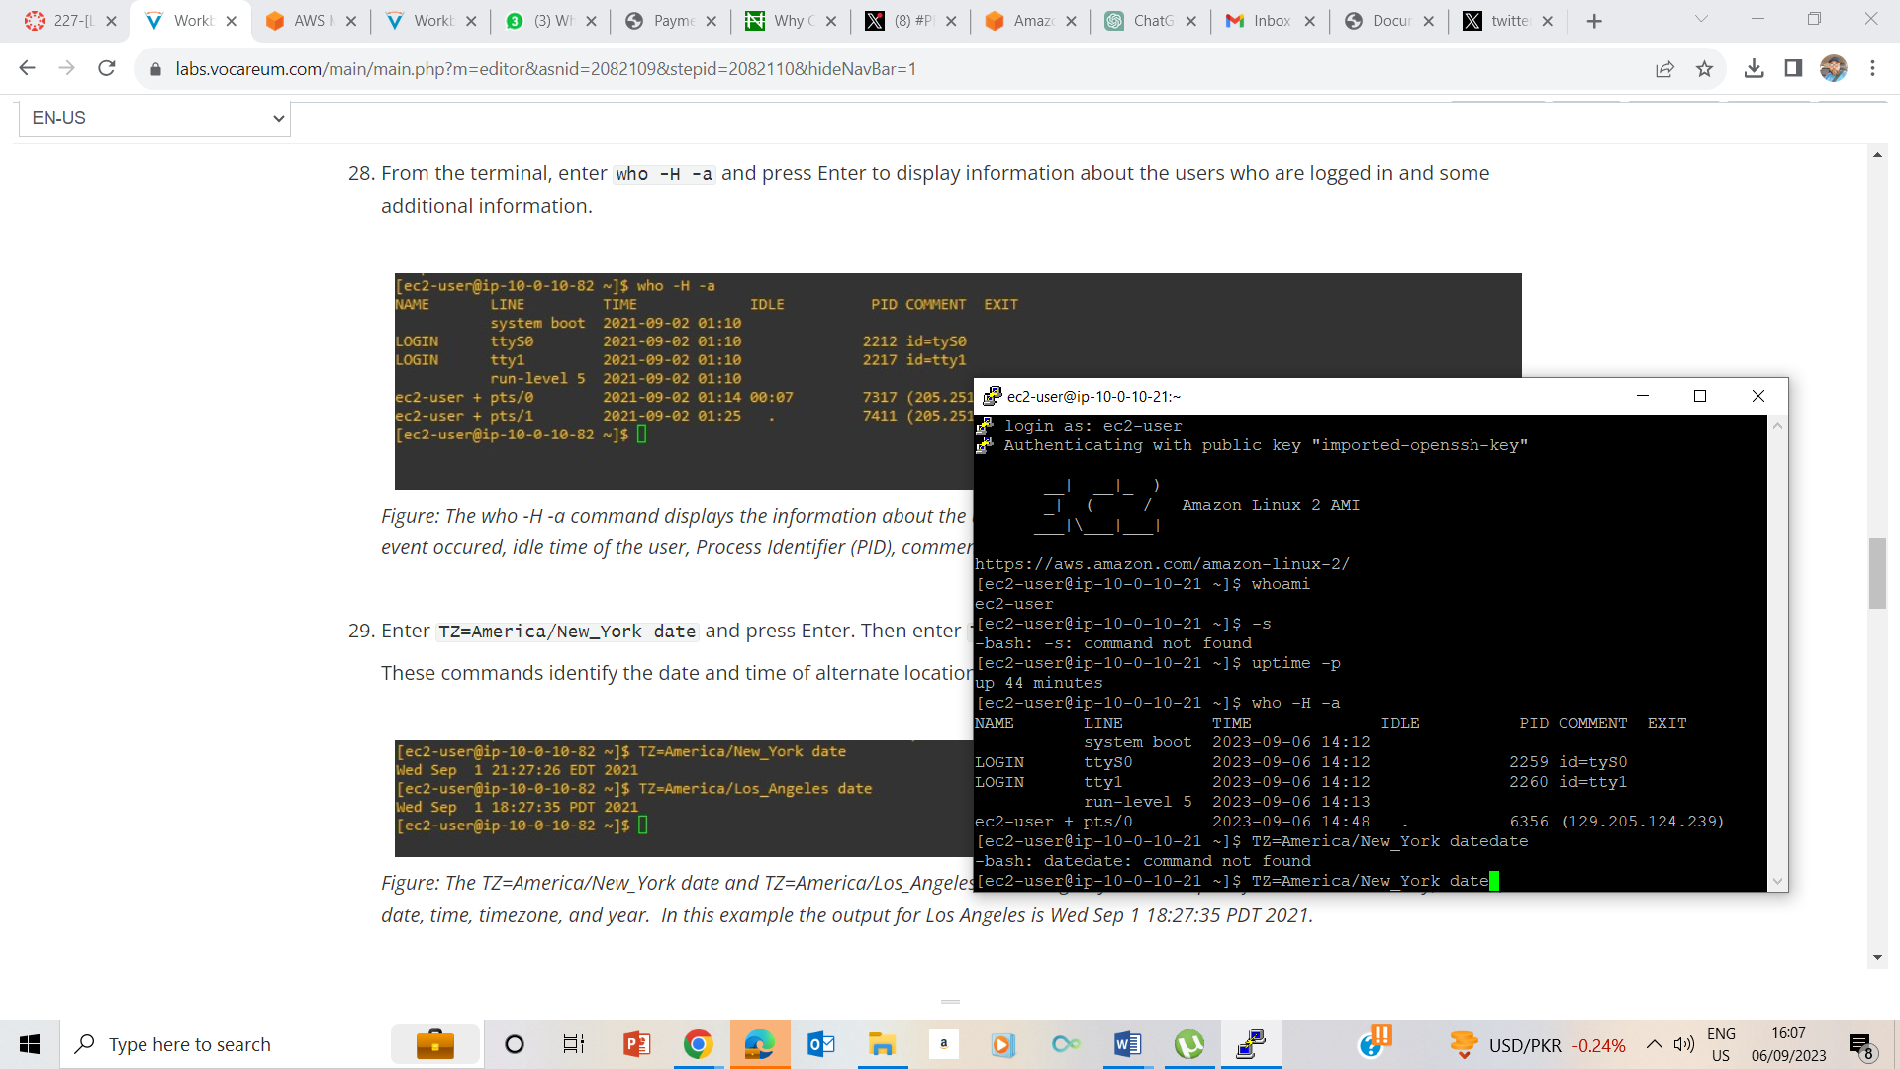

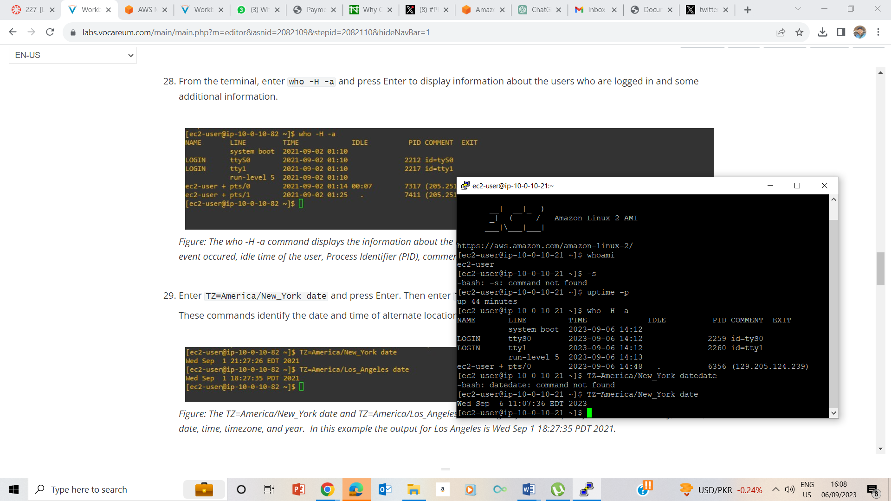

30.

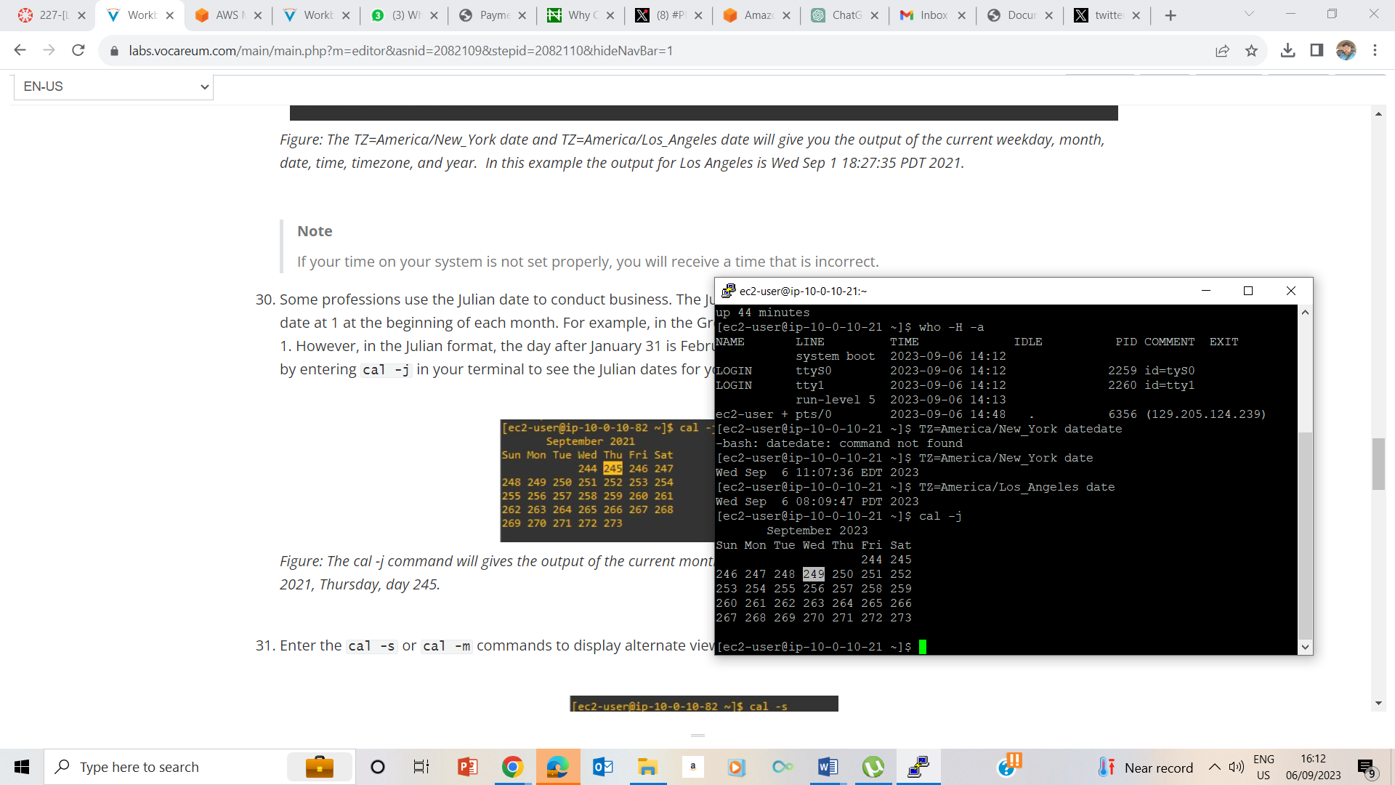

New York and Los Angeles date and time. TZ=America/New_York date and TZ=America/Los_Angeles date

32

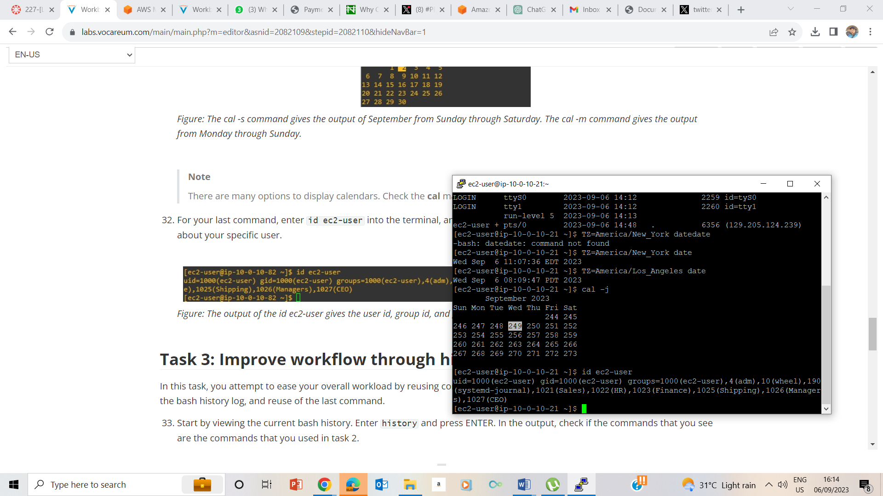

Cal –j is the Julian format of the calender

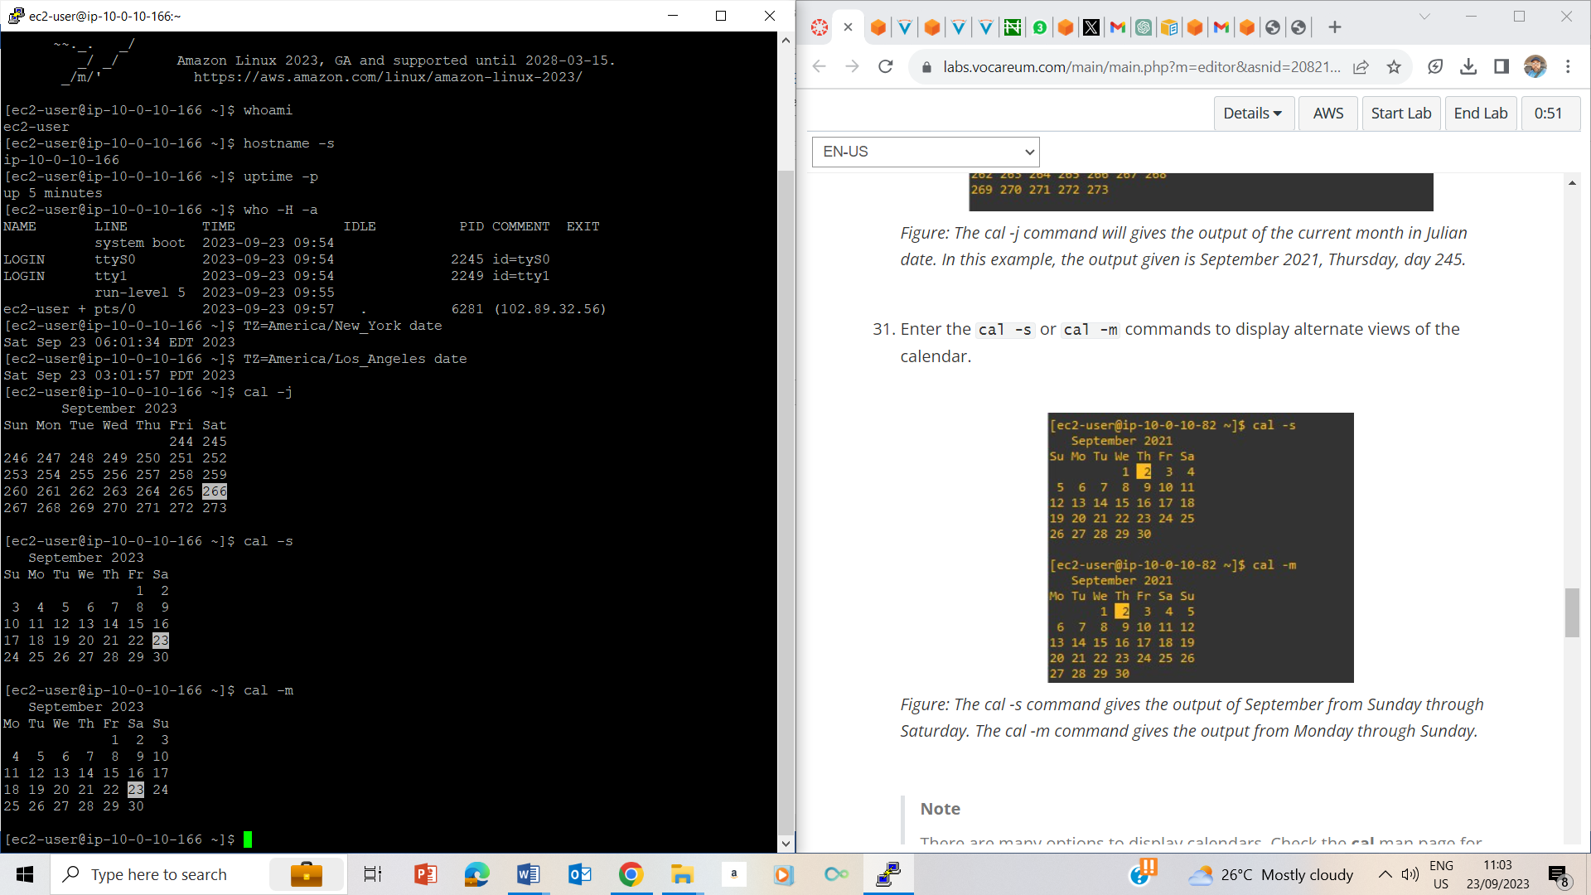

Cal –s and cal –m displays calender month starting from Sunday and Monday respectively.

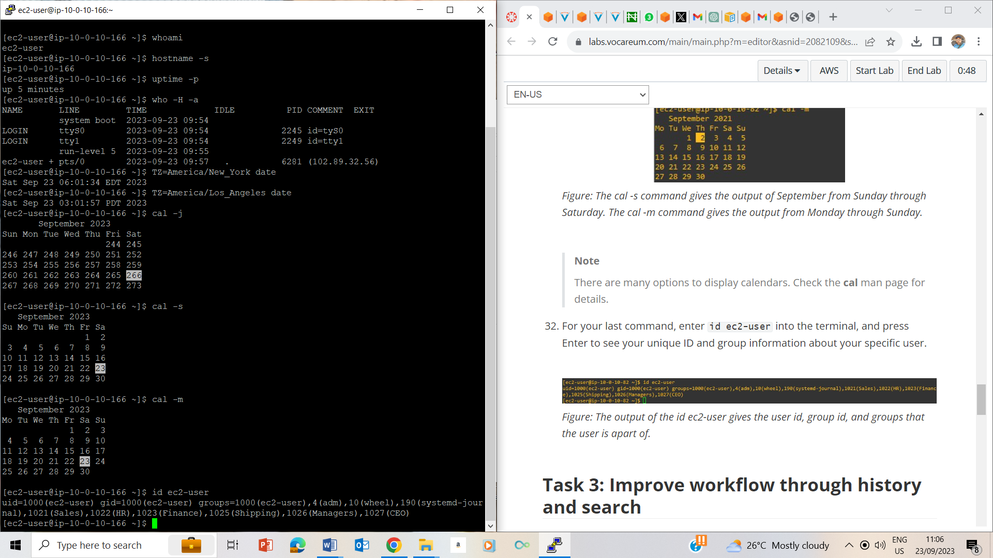

Id ec2-user brings out unique identity of the user.

## Task 3: Improve workflow through history and search

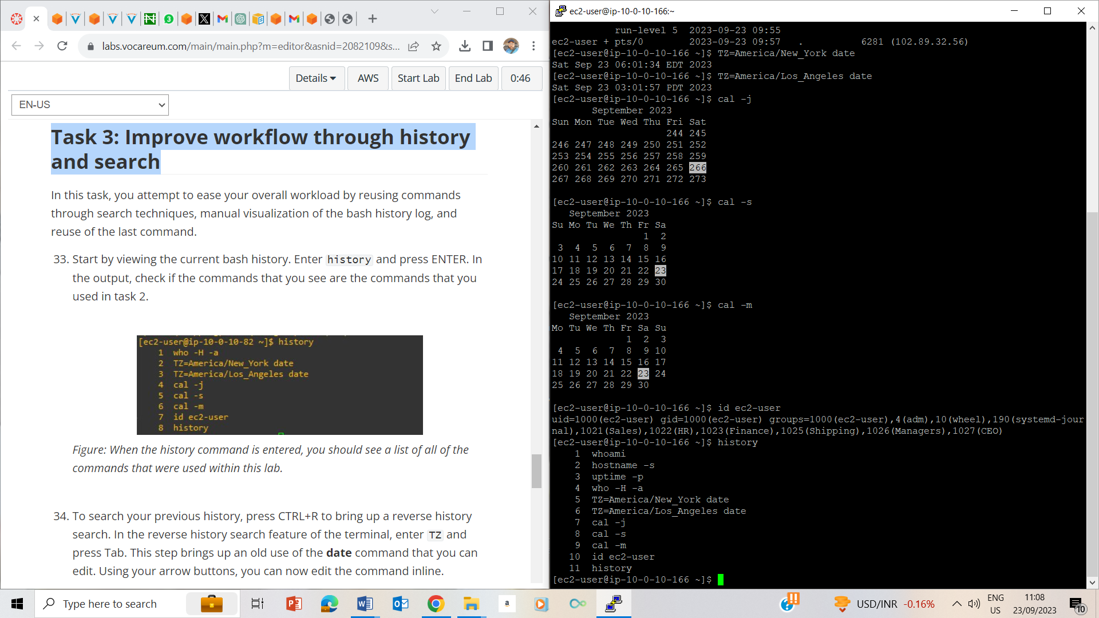

33. history commands brings out all previous commands entered

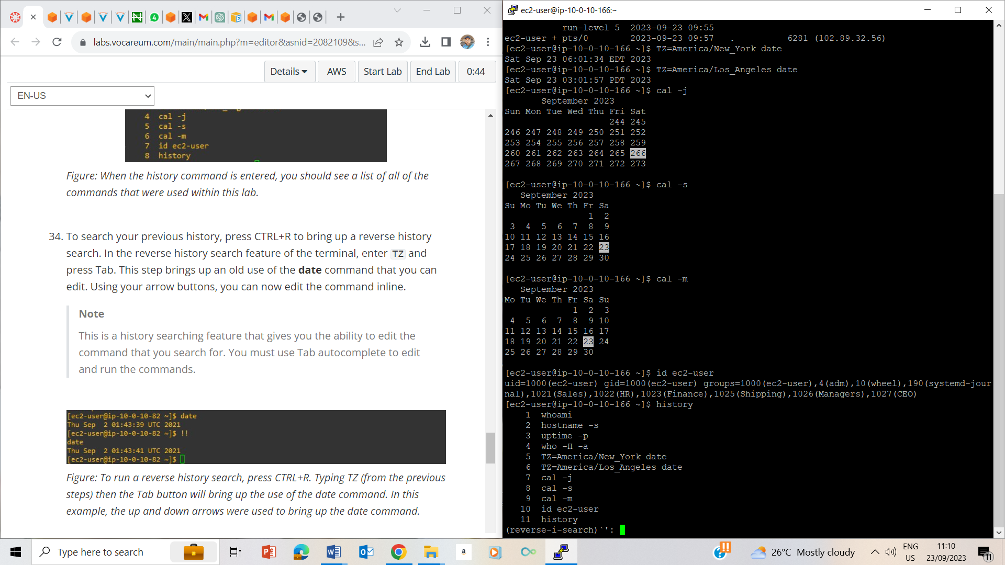

CTRL +R brings out reverse search

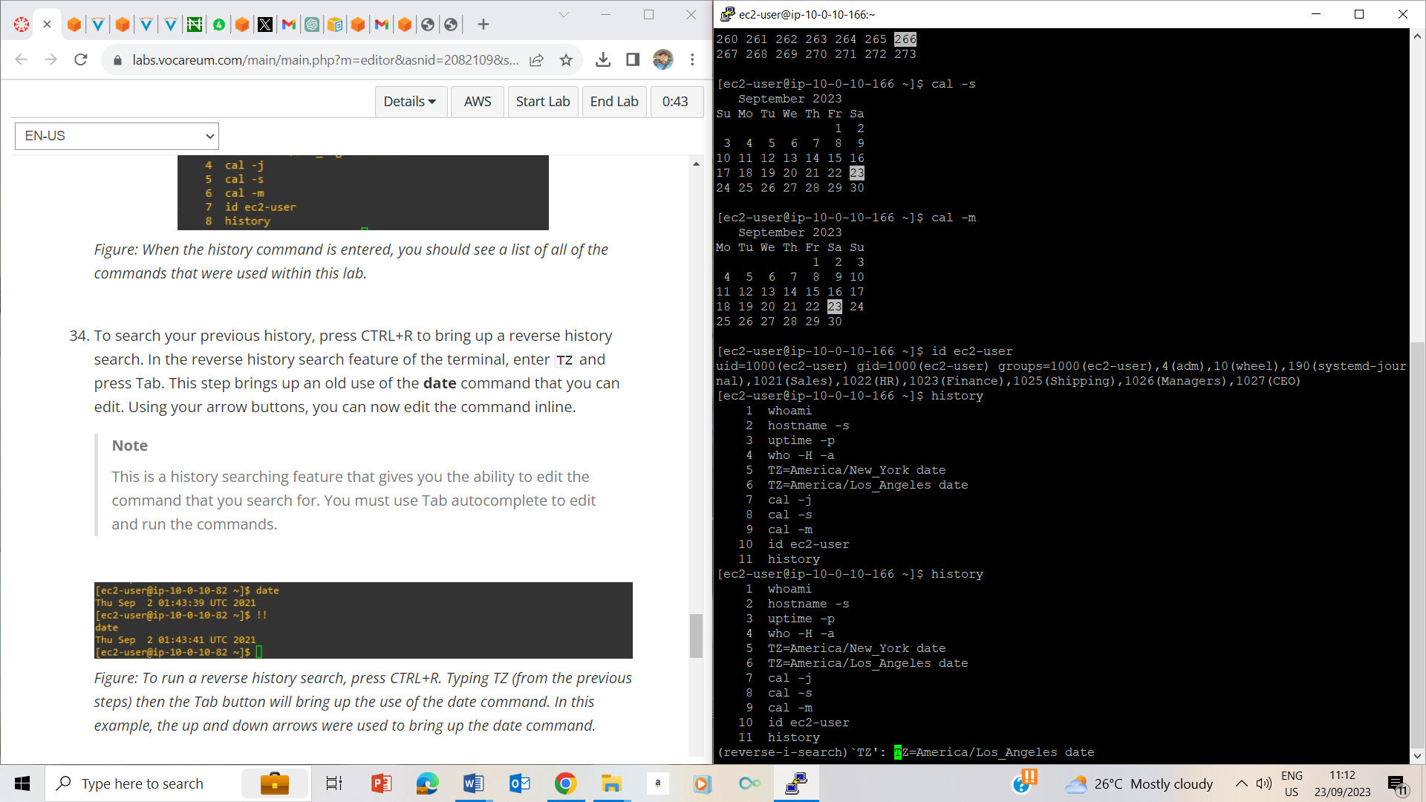

CTRL+R and entering tz on the prompt brings out an old use of date command that one can edit.

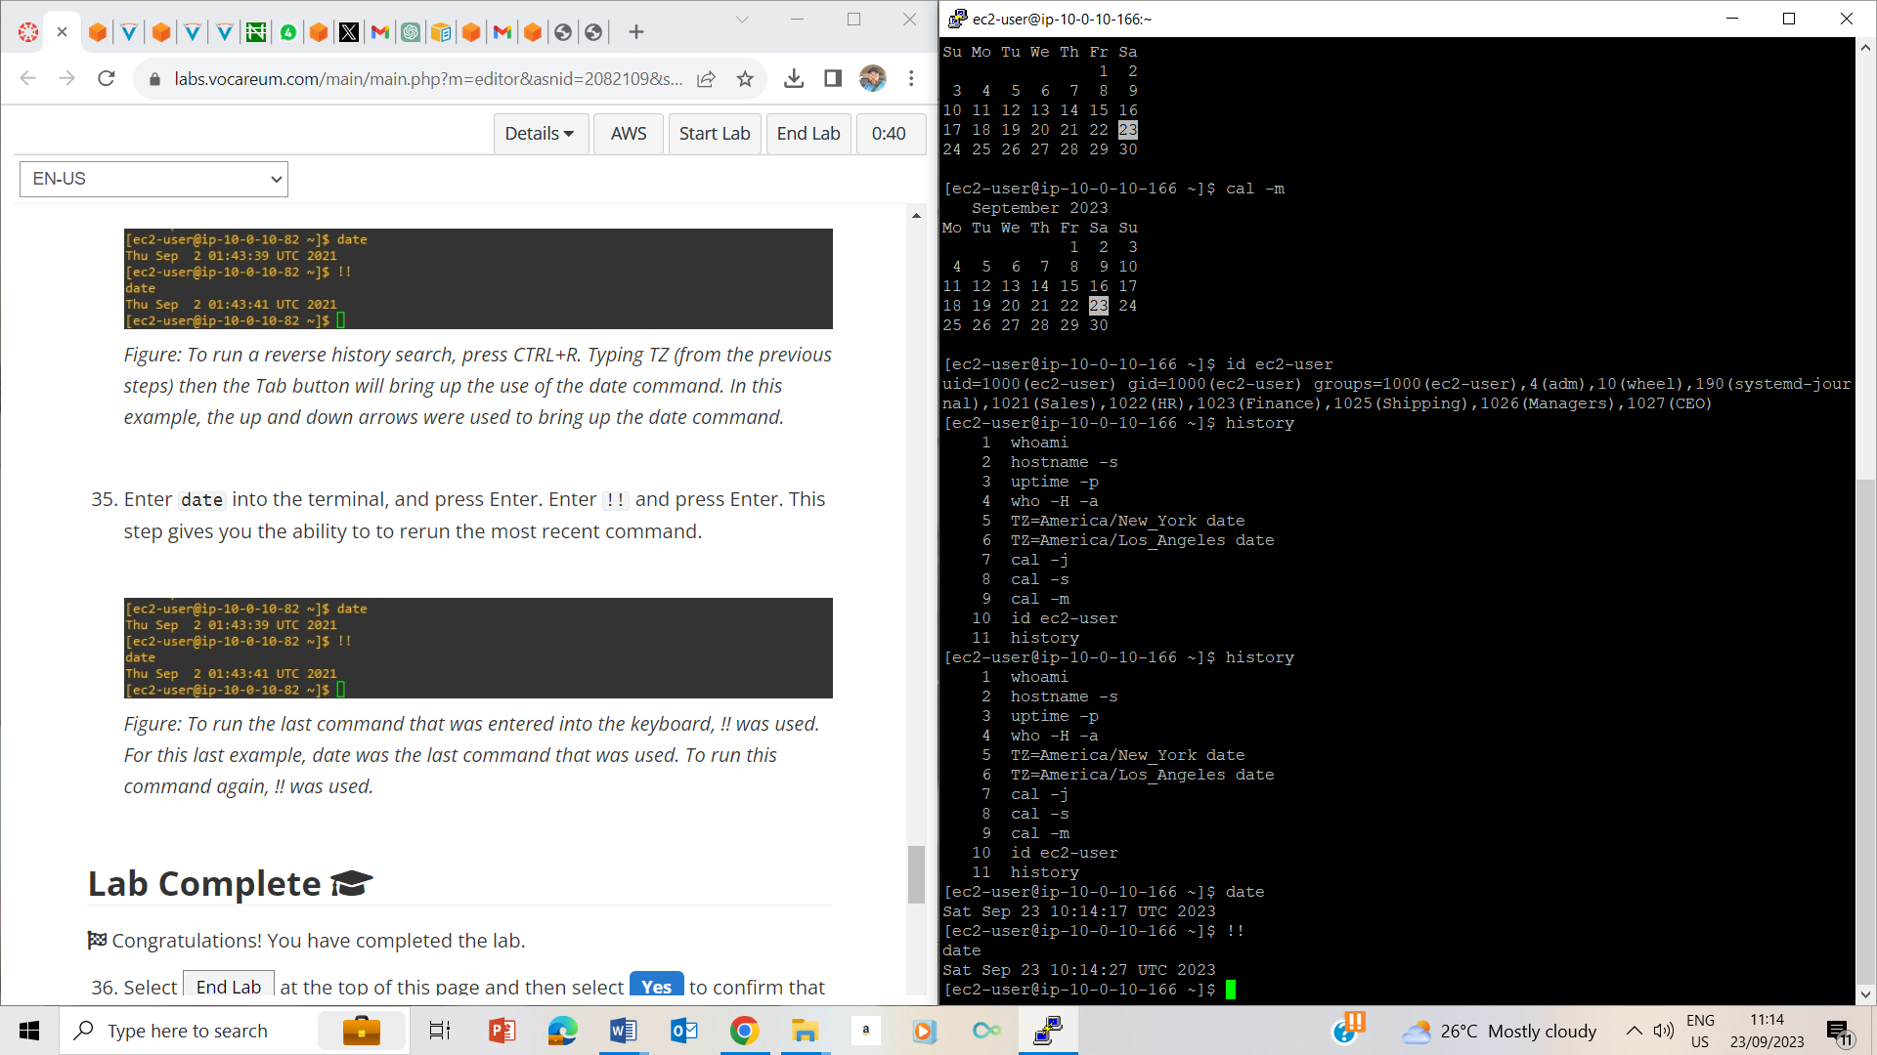35. Entered date into the terminal and then entered !! and pressed enter, gives me the ability to return the most recent command; since date was the last command, it ran again by showing the current date.

## Lab Complete

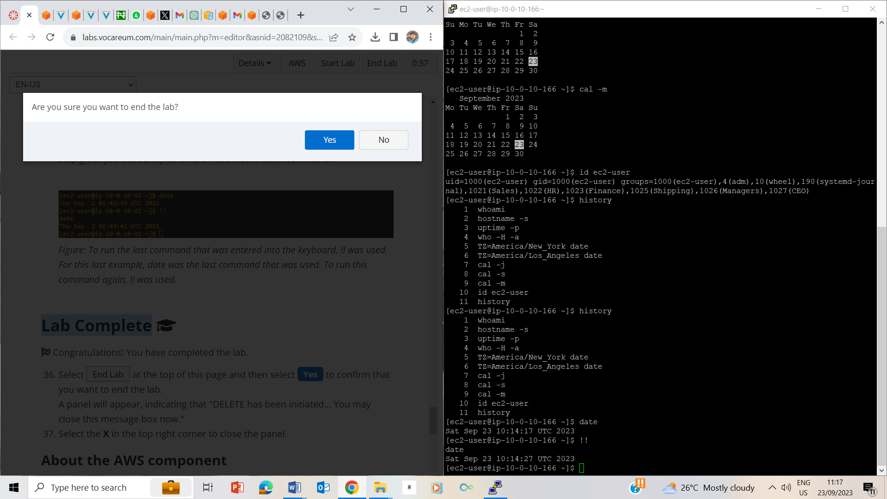

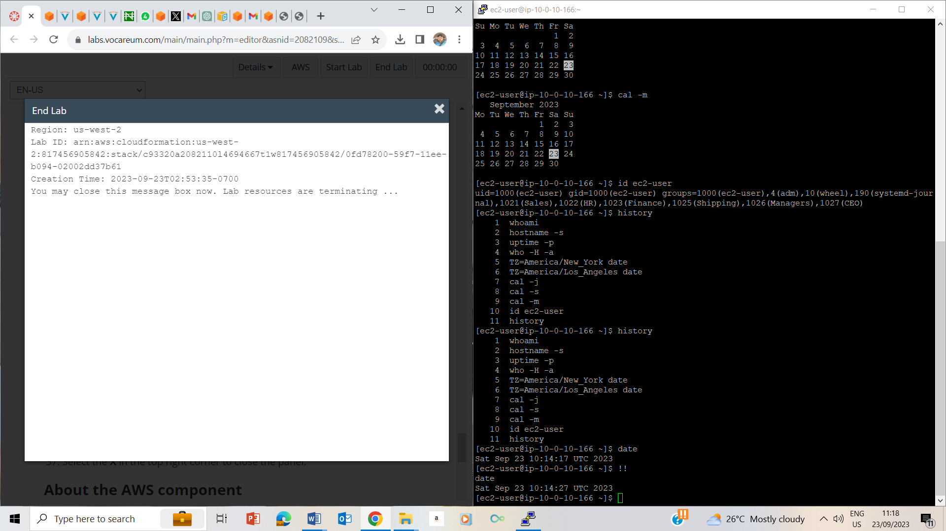

Ended the lab and closed configurations